
- Home
- Professional Pronouncements
- Standard Setting
- ISSAIs in Action
- About
- Contact

About the INTOSAI Framework of Professional Pronouncements – IFPP
- Home>
- About the INTOSAI Framework of Professional Pronouncements – IFPP
INTOSAI Professional Pronouncements are the formal and authoritative announcements or declarations of the INTOSAI Community. They draw on the collective professional expertise of INTOSAI’s members and provide INTOSAI’s official statements on audit-related matters. All the pronouncements are organised and numbered according to their status and purpose in a single framework.
This framework – The INTOSAI Framework of Professional Pronouncements (IFPP) – contains three categories of professional pronouncements:

The INTOSAI Principles (INTOSAI-P)
The INTOSAI Principles consist of founding principles and core principles. The founding principles have historical significance and specify the role and functions, which SAIs should aspire to. These principles may be informative to Governments and Parliaments, as well as SAIs and the wider public and may be used as reference in establishing national mandates for SAIs.
The core principles support the founding principles for an SAI, clarifying the SAI’s role in society as well as high level prerequisites for its proper functioning and professional conduct.

The International Standards of Supreme Audit Institutions (ISSAI)
The ISSAIs are the authoritative international standards on public sector auditing. The purpose of the ISSAIs is to:
- ensure the quality of the audits conducted
- strengthen the credibility of the audit reports for users
- enhance transparency of the audit process
- specify the auditor’s responsibility in relation to the other parties involved
- define the different types of audit engagements and the related set of concepts that provides a common language for public sector auditing.
The full set of ISSAIs is based on a basic set of concepts and principles that defines public sector auditing and the different types of engagements supported by the ISSAIs.

The INTOSAI Guidance (GUID)
The guidance is developed by INTOSAI in order to support the SAI and individual auditors in:
- How to apply the ISSAIs in practice in the financial, performance or compliance audit processes
- How to apply the ISSAIs in practice in other engagements
- Understanding a specific subject matter and the application of the relevant ISSAIs

Find out how the IFPP replaces the former ISSAI framework (download a PDF chart):
English French German Spanish (Arabic soon!)
A number of pronouncements are currently under review and can be accessed here.

Clarification on ISSAI 2200-2999 Financial Auditing Standards (formerly the ISSAI1200-1999 series)
INTOSAI has adopted a dual approach when it comes to the development of audit guidance in the public sector. Either we develop our own standards building on material from other standard-setting bodies after adapting the principals involved for a public sector perspective, or where relevant we use the standards of other bodies directly. Financial Auditing Standards can be accessed directly at the International Auditing and Assurance Standards Board (IAASB) website free of charge. Please see here how to access the standards.
The Financial Auditing Standards will continue to be numbered individually in the IFPP, but the ISSAI-numbers 2200-2999 will be used instead of the 1200-1999 series. This means that the numbering in the range ISSAI 2200-2810 will follow the principle that the International Standards on Auditing (ISA) no. xxx is included as ISSAI 2xxx in the IFPP.

INTOSAI Standard setting process
The Due Process for the IFPP establishes the procedures to develop, revise and withdraw professional pronouncements. The process starts with a project proposal.
All intended projects must be included in the Strategic Development Plan (SDP) for that period. The SDP is developed in consultation with Supreme Audit Institutions, INTOSAI working bodies and external stakeholders. The INTOSAI Governing Board endorses the SDP. It is launched at the triennial Congress of the Supreme Audit Institutions. More about the Forum for INTOSAI Professional Pronouncements, visit their website www.intosaifipp.org
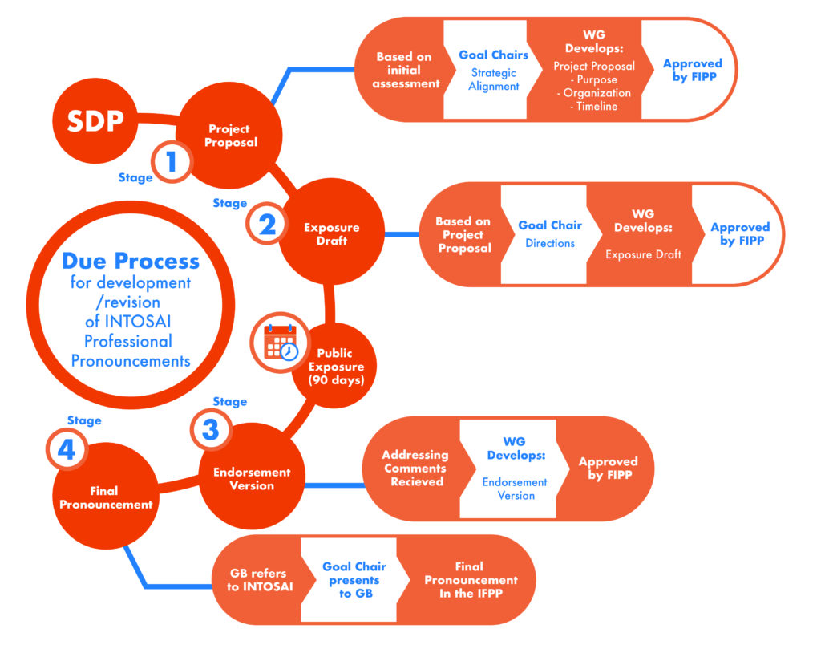

Click here to see a short video about the Due Process for INTOSAI Professional Pronouncements
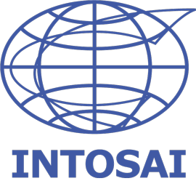
MISSION: The International Organisation of Supreme Audit Institutions - INTOSAI - is an autonomous, independent, professional, and nonpolitical organization established to provide mutual support; foster the exchange of ideas, knowledge, and experiences; act as a recognized voice of SAIs within the international community; provide high quality auditing standards for the public sector; promote good governance; and foster SAI capacity development and continuous performance improvement.
VISION: Promote good governance by enabling SAIs to help their respective governments improve performance, enhance transparency, ensure accountability, maintain credibility, fight corruption, promote public trust, and foster the efficient and effective receipt and use of public resources for the benefit of their citizens.

The Professional Standards Committee – PSC – is responsible for the overall coordination of INTOSAI standards setting process. Through its work, the PSC seeks to contribute to the development and adoption of INTOSAI pronouncements.

Supporting documents
- Due ProcessPDF format –504 kb
- Strategic Development Plan 2016-2019PDF format – 2mb
- Strategic Development Plan 2020-2022PDF format - 8mb
Classification principles
………………………………………….

